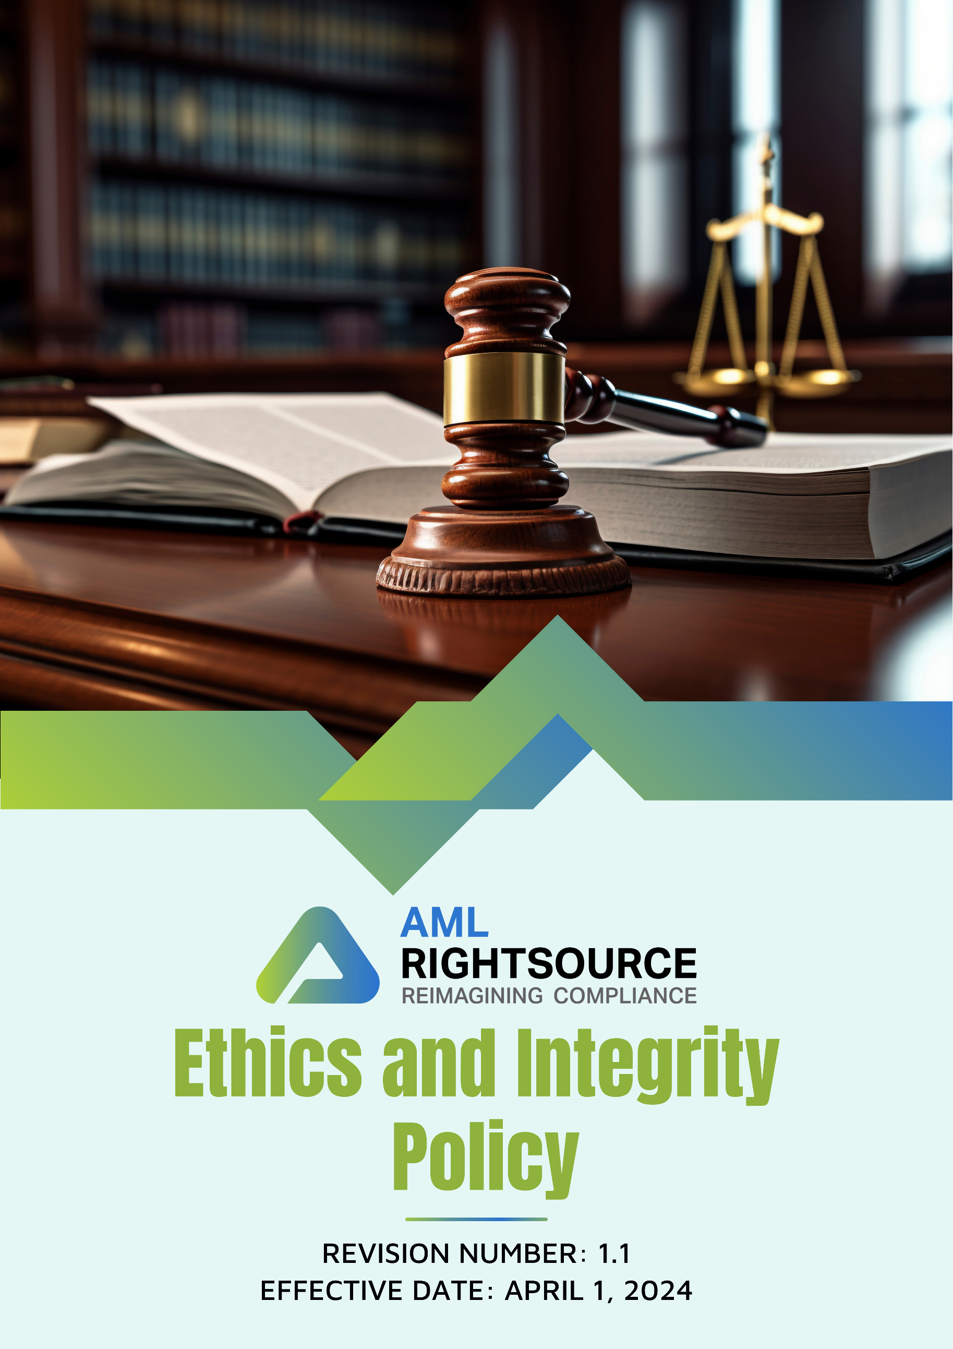
Contents
INTRODUCTION 3
SCOPE 3
PURPOSE OF THIS POLICY 4
OUR FOCUS AREAS 4
QUALITATIVE GOALS 6
QUANTITATIVE GOALS 9
RESPONSIBILITY 11
EMPLOYEE GUIDELINES 12
CONSEQUENCES OF VIOLATION OF THIS POLICY 14
REPORTING 15
CONTINUOUS IMPROVEMENT 16
REVIEW MECHANISM 16
EMPLOYEE ACKNOWLEDGEMENT FORM 17

INTRODUCTION
THE AML RIGHTSOURCE GROUP of companies (referred to herein as “AMLRS”) is committed to upholding the highest standards of ethics and integrity in all aspects of its operations. As a leader in financial crime compliance, the group recognizes the critical importance of fostering a culture of transparency, accountability, and ethical behavior. We are dedicated to ensuring that our business practices are aligned with the principles of fairness, honesty, and legal compliance. This approach underpins our mission to provide effective solutions to clients while safeguarding against financial crime and ensuring adherence to regulatory frameworks. Our commitment to ethics and integrity is reflected in the actions of our leadership, employees, and partners, who are expected to embody these values in every decision and interaction. This framework supports our goal to continually strengthen trust and maintain the reputation of THE AML RIGHTSOURCE GROUP as a trusted leader in the industry.

SCOPE
This Ethics and Integrity Policy applies to all operations, legal entities, offices, partner offices, registered business addresses, remote work locations, and other workplaces of the AML RightSource Group of Companies ("AMLRS"), including all subsidiaries, affiliates, and controlled entities operating in the United States, Canada, Germany, Poland, Austria, Switzerland, the United Kingdom, Denmark, Bulgaria, India, Singapore, Hong Kong, Brazil, and Malaysia, as well as any future locations where AMLRS conducts business.
The policy applies irrespective of whether business activities are carried out from AMLRS-owned or leased premises, partner offices, co-working spaces, client locations, registered legal addresses, or remote work environments. It covers all employees, including full-time, part-time, temporary, fixed-term, and contract employees, interns, consultants, agency workers, and management. The policy also extends to suppliers, vendors, contractors, service providers, business partners, and any other third parties engaged in providing products or services on behalf of AMLRS.
All individuals and entities covered by this policy are expected to comply with its requirements and uphold AMLRS's commitment to conducting business ethically, honestly, transparently, and with integrity. This includes complying with applicable laws and regulations, preventing bribery, corruption, fraud, conflicts of interest, and other unethical conduct, and maintaining high standards of professional and responsible business conduct throughout AMLRS's global operations.

PURPOSE OF THIS POLICY
The purpose of this policy is to establish a clear framework for promoting ethical conduct, ensuring integrity in decision-making, and fostering compliance with legal and regulatory standards, reinforcing THE AML RIGHTSOURCE GROUP’s commitment to combating financial crime and maintaining organizational trustworthiness.

OUR FOCUS AREAS
- Prevention of Corruption and Bribery
- Foster a culture of integrity and ethical conduct across all levels of the organization.
- Promote accountability and transparency in business operations and stakeholder engagements.
- Uphold compliance with global standards and regulations to prevent corruption and bribery.
- Encourage ethical decision-making and fairness in all professional interactions.
- Strengthen trust and credibility by prioritizing honesty and ethical business practices.
- Information Security
- Foster a culture of awareness and responsibility for protecting sensitive information at all organizational levels.
- Promote compliance with legal and regulatory requirements to safeguard data confidentiality, integrity, and availability.
- Strengthen trust by prioritizing transparency and accountability in data protection practices.
- Encourage vigilance and ethical handling of information in day-to-day operations.
- Ensure alignment with global standards to mitigate risks related to data security threats.
- Managing Conflicts of Interest
- Maintain transparency and fairness in all professional relationships and decision-making processes.
- Foster an organizational culture that prioritizes objectivity over personal interests.
- Encourage employees to disclose any potential conflicts to uphold trust and integrity.
- Promote accountability by ensuring professional responsibilities remain unaffected by external influences.
- Strengthen ethical standards to prevent situations that may compromise impartiality.
- Fraud Prevention and Detection
- Foster a workplace environment that values honesty, transparency, and ethical behaviour.
- Promote accountability and vigilance in identifying and addressing potential fraud risks.
- Uphold compliance with laws and standards to ensure fraud prevention across all operations.
- Build trust by emphasizing integrity and fairness in business practices.
- Strengthen awareness to create a proactive approach toward fraud detection and reporting.
- Anti-Money Laundering
- Promote a commitment to preventing money laundering in all business operations and financial transactions.
- Uphold strict compliance with international anti-money laundering laws and regulations.
- Foster a culture of vigilance, ensuring that suspicious activities are promptly identified and addressed.
- Encourage transparency and accountability in financial practices to deter money laundering risks.
- Strengthen relationships with partners and stakeholders by ensuring shared responsibility for combating money laundering.

QUALITATIVE GOALS
- Prevention of Corruption and Bribery
- We will implement regular internal audits to minimize the risk of corruption and bribery across all business areas.
- Our anti-bribery framework will be reviewed annually to ensure compliance with global anti-corruption regulations and uphold ethical business practices.
- We will enforce rigorous due diligence processes for third-party partners to ensure alignment with our anti-bribery policies.
- Engaging, scenario-based training will be provided to employees, helping them recognize and prevent bribery and corruption.
- A secure, anonymous reporting platform has been developed via the AMLRS Ethics Portal, empowering employees to report suspected bribery incidents without fear of retaliation.
- Information Security
- We will conduct detailed, regular audits to ensure that data protection measures are implemented correctly and maintained consistently across all operations.
- Our information security protocols will be reviewed and updated annually to align with the latest cybersecurity advancements and emerging risks.
- Comprehensive, tailored cybersecurity training will be provided to employees, ensuring they are equipped to protect sensitive data effectively.
- We will implement best practice multi-factor authentication (MFA) methods to enhance secure access to sensitive systems and data.
- Our strategy includes collaborating with cybersecurity experts to conduct periodic reviews, continually strengthening our data protection practices.
- Managing Conflicts of Interest
- We will identify and address conflicts of interest through self-assessments and transparent reporting, ensuring ethical decisions.
- We will establish clear guidelines to help employees identify and avoid situations that may lead to conflicts of interest.
- A mandatory disclosure process will be implemented, requiring employees to report any personal interests that could compromise professional decisions.
- Training programs will educate employees on recognizing, mitigating, and managing potential conflicts of interest effectively.
- A confidential Ethics Portal has been introduced, enabling employees to seek advice or report concerns related to conflicts of interest without fear of reprisal.
- Fraud Prevention and Detection
- We will implement robust internal controls and monitoring systems to detect and prevent fraudulent activities effectively.
- Annual fraud risk assessments will be conducted to identify vulnerabilities and strengthen preventive measures.
- Employees will receive targeted training to recognize, report, and mitigate fraudulent activities in their roles.
- A secure whistleblowing system has been introduced via the AMLRS Ethics Portal, ensuring employees can report suspected fraud confidentially and without retaliation.
- Collaboration with external auditors and forensic experts will enhance fraud detection and response strategies.
- Anti-Money Laundering
- We will implement stringent AML controls to detect and prevent illicit financial activities across all business operations.
- Regular risk assessments will identify vulnerabilities in transactions and strengthen safeguards against money laundering.
- Employees will undergo specialized training to recognize and report suspicious activities in compliance with AML regulations.
- A secure, centralized reporting system will be established to ensure timely reporting of suspicious transactions to relevant authorities.
- Collaborations with regulatory bodies will ensure our AML practices remain aligned with evolving global standards.

QUANTITATIVE GOALS
- Corruption
- Our target goal is to reach a 95% success rate in anti-bribery compliance checks by 2030, improving upon our assessment levels from 2022.
- We aim to sustain 100% compliance with anti-corruption guidelines, ensuring ethical practices across all operations in alignment with our 2022 benchmarks.
- We are dedicated to achieving 100% employee participation in anti-bribery training programs by 2030, significantly expanding from our baseline in 2022.
- We are committed to maintaining a 0 confirmed corruption cases to reinforce our ethical standards.
- Information Security
- Our target goal is to achieve a 95% security compliance rate in annual audits by 2030, demonstrating significant progress from our status in 2022.
- We are committed to maintaining full compliance with information security standards, ensuring robust data and system protection, based on our baseline in 2022.
- We aim to enhance employee participation in information security training, achieving 100% engagement by 2030, building on participation levels from 2022.
- Our objective is to reduce potential information security incidents by 40% by 2030, achieving an improvement from the baseline incident rate in 2022.
- We strive to uphold a 0% confirmed information security breaches to protect the integrity and confidentiality of all data.
- Managing Conflicts of Interest
- We aim to achieve a target goal of a 90% compliance rate in annual conflict of interest declarations by 2030, reflecting progress from our 2022 baseline.
- Our objective is to ensure 100% adherence to conflict-of-interest guidelines, promoting transparency and accountability across all operations, based on 2022 benchmarks.
- We are committed to training 100% of employees on conflict-of-interest awareness by 2030, expanding participation from 2022 levels.
- Our strategy focuses on reducing reported conflict-of-interest cases by 50% by 2030, implementing proactive measures from the baseline identified in 2022.
- Fraud Prevention and Detection
- Our goal is to achieve a 90% fraud detection rate in internal audits by 2030, enhancing vigilance from our detection capabilities in 2022.
- We are committed to ensuring 100% compliance with fraud prevention guidelines, reinforcing employee responsibility to prevent fraud, as established in 2022.
- We aim to achieve 100% employee participation in fraud awareness training by 2030, building a strong understanding across the organization from our 2022 baseline.
- Our objective is to maintain 0 confirmed fraud cases, ensuring ethical business practices and integrity.
- Anti-Money Laundering
- Our commitment is to maintain 100% compliance with anti-money laundering guidelines, fostering ethical practices by 2030.
- We aim to achieve 100% employee participation in money laundering awareness training by 2030, promoting a culture of diligence and compliance from our 2022 baseline.
- Our objective is to maintain zero money laundering cases every year creating a safer financial environment based on 2022 reports.

RESPONSIBILITY
The Lead Compliance Officer is responsible for implementing this policy and ensuring all Partners and employees are aware of and adhere to this Policy.
- Executive Management
- Foster a culture of ethical decision-making at all levels.
- Integrate governance practices into the company’s strategy.
- Encourage the allocation of, and deploy available resources, for implementing the Ethics and Integrity Policy.
- Regularly assess compliance across departments and take corrective actions when necessary.
- Encourage that governance-related metrics be included in employee performance reviews for executives and senior leaders.
- Maintain open communication with stakeholders about governance practices.
- Lead Compliance Officer
- Ensure the Ethics and Integrity Policy aligns with organizational objectives.
- Conduct an annual review to assess policy effectiveness.
- Maintain confidential, accessible reporting systems.
- Identify and manage compliance risks across the organization.
- Lead internal audits to evaluate governance and compliance across departments.
- Employees
- Adhere to the Ethics and Integrity Policy and ethical standards.
- Report concerns or violations through internal channels.
- Participate in governance-related training programs.
- Actively participate in internal audits and assessments.
- Take initiative to identify and address governance-related issues.
- Safeguard confidential information and report any breaches.
- Encourage colleagues to uphold governance standards and ethical practices.

EMPLOYEE GUIDELINES
Employees are expected to conduct themselves with honesty, integrity, professionalism, and accountability in all business activities. The following guidelines illustrate expected ethical behaviour.
Guideline | Example of Ethical Behaviour
Act with Integrity | Always be truthful and transparent in your work.  Example: If you discover an error in a client report, immediately inform your manager and correct it instead of concealing the mistake.
Comply with Laws and Company Policies | Follow all applicable laws, regulations, and company procedures.  Example: Complete all mandatory compliance and AML training before the due date and follow internal approval processes.
Avoid Conflicts of Interest | Do not allow personal interests to influence business decisions.  Example: Inform your manager if a close family member works for a vendor participating in a procurement process.
Prevent Bribery and Corruption | Never offer, accept, or request anything of value that could improperly influence a business decision.  Example: Politely decline an expensive gift from a supplier during contract negotiations and report it according to company procedures.
Protect Confidential Information | Keep client, employee, and company information secure and confidential.  Example: Do not discuss confidential client information in public places or share files with unauthorized individuals.
Maintain Accurate Records | Ensure all business records and reports are accurate, complete, and timely.  Example: Record working hours and expenses honestly without falsifying information.
Respect Others | Treat everyone with dignity, fairness, and respect.  Example: Listen respectfully to colleagues' opinions during meetings and avoid discriminatory or offensive language.
Promote an Inclusive Workplace | Support equal opportunity and value diversity.  Example: Evaluate candidates based on their qualifications rather than their age, gender, religion, or ethnicity.
Use Company Resources Responsibly | Use company assets only for legitimate business purposes.  Example: Use company laptops, software, and internet access responsibly and avoid installing unauthorized applications.
Maintain Information Security | Follow cybersecurity requirements to protect company systems.  Example: Use strong passwords, enable multi-factor authentication, and immediately report suspicious emails or phishing attempts.
Speak Up and Report Concerns | Report suspected unethical behaviour or policy violations without fear of retaliation.  Example: Report suspected fraud, data manipulation, or harassment through the company's reporting mechanism or ethics hotline.
Cooperate During Investigations | Provide honest and complete information during internal investigations or audits.  Example: Submit requested documents promptly and answer investigators truthfully.
Be Accountable | Take responsibility for your actions and decisions.  Example: If a compliance requirement is missed, report it immediately and work with your manager to implement corrective actions.
Use Social Media Responsibly | Do not post confidential information or comments that may harm the company's reputation.  Example: Avoid sharing client information, internal meetings, or confidential projects on personal social media accounts.
Seek Guidance When Unsure | Ask for advice before taking actions that may create ethical or compliance concerns.  Example: Consult your manager or Compliance team before accepting hospitality from a business partner if you are unsure whether it complies with company policy.
Remember the Ethics Test
Before making a decision, ask yourself:
- Is it legal?
- Is it consistent with the company's policies and values?
- Would I be comfortable if this decision were made public?
- Would I be comfortable explaining this decision to my manager, colleagues, client, or regulator?
- Could this action create a conflict of interest or damage the company's reputation?
If the answer to any of these questions is "No" or "I'm not sure," stop and seek guidance from your manager, Human Resources, Legal, or the Compliance team before proceeding.

CONSEQUENCES OF VIOLATION OF THIS POLICY
- Disciplinary Measures: Employees who breach governance guidelines may face disciplinary actions ranging from verbal warnings to formal reprimands, depending on the seriousness of the violation.
- Termination: Repeated or severe violations, particularly those involving ethical misconduct like fraud or corruption, may lead to immediate termination of employment.
- Legal Repercussions: Violations that breach laws or regulations may result in legal action, including civil or criminal charges, which could lead to fines or imprisonment.
- Loss of Benefits: Employees found in violation may lose access to certain company benefits, such as bonuses, promotions, or eligibility for specific roles.
- Compulsory Retraining: Employees who breach governance guidelines may be required to attend additional training focused on compliance, ethics, and applicable laws.
- Damage to Reputation: Violations can damage the organization’s reputation, leading to diminished client trust, strained partnerships, and negative publicity.
- Financial Penalties: The organization may incur fines from regulatory bodies for non-compliance with laws or governance violations.
- Increased Oversight: Following a violation, the organization may face heightened scrutiny from internal auditors, regulators, and stakeholders, leading to more stringent oversight.
- Internal Investigation: A breach may prompt an internal investigation, evaluating processes and controls to identify weaknesses and prevent recurrence.
- Career Setbacks: Employees who violate governance guidelines may experience hindered career progression, limiting future opportunities for growth and advancement.

REPORTING
Regular and transparent reporting practices are essential for tracking progress, identifying potential risks, and maintaining accountability in ethics and governance. AMLRS follows these reporting procedures:
- Annual Reviews: We conduct annual evaluations of our ethics performance, collecting data on key metrics defined in our governance framework.
- Internal Audits: Regular internal audits are conducted to ensure compliance with ethical standards, evaluate the effectiveness of governance systems, and identify opportunities for improvement.
- Stakeholder Communication: We engage with stakeholders, including employees, customers, regulators, and local communities, to gather insights, address concerns, and transparently communicate our governance progress and initiatives.

CONTINUOUS IMPROVEMENT
THE AML RIGHTSOURCE GROUP is dedicated to continuously enhancing our ethics and integrity standards. We regularly review and update our Ethics and Integrity Policy, integrating best practices, new technologies, and stakeholder feedback. Our efforts prioritize promoting ethical conduct, transparency, and accountability across all operations.
We actively seek innovative solutions, improve decision-making processes, and engage employees through targeted training. By fostering a culture of integrity and ethical behavior, we aim to exceed regulatory expectations and uphold the highest standards of business ethics.

REVIEW MECHANISM
The Lead Compliance Officer will review the Ethics and Integrity Policy annually, and any updates will be communicated as necessary.
Sr. No. | Effective Date | Reviewer | Approver | Change Summary
1 | April 01, 2024 | Lead Compliance Officer | AMLRS RIGHTSOURCE (GROUP) | New Policy
2 | April 01, 2025 | Lead Compliance Officer | AMLRS RIGHTSOURCE (GROUP) | Cosmetic Changes
3 | April 01, 2026 | Lead Compliance Officer | AMLRS RIGHTSOURCE (GROUP) | Employee Guidelines
Next review date: April 01, 2027

Prepared by: Lead Compliance Officer (General Counsel, AML RightSource, LLC)
Approved by: AML RIGHTSOURCE GROUP

EMPLOYEE ACKNOWLEDGEMENT FORM
I, the undersigned, confirm that I have received and reviewed the Ethics and Integrity Policy of THE AML RIGHTSOURCE GROUP. I understand the company's dedication to upholding high ethical standards and its commitment to fostering integrity, transparency, and accountability in all its operations.
By signing this acknowledgment, I commit to adhering to the ethical practices and guidelines outlined in the policy, and I will actively support the company’s efforts to maintain a culture of honesty and fairness.
I will participate in any necessary training programs related to ethics and integrity and contribute positively to achieving THE AML RIGHTSOURCE GROUP's ethical and integrity objectives.
Employee Information
- Name:
- Signature:
- Date:

